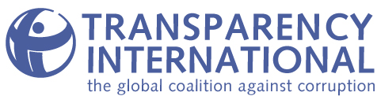

Report on the
Transparency International
Global Corruption Barometer 2007

Embargoed until Thursday
6 December 2007 at 9:00 GMT

Release date: 6 December 2007
Policy and Research Department
Transparency International – International Secretariat
Alt Moabit 96
10559 Berlin, Germany
Tel: + 49-30-34 38 200
Fax: +49-30-34 70 39 12

Executive Summary – Global Corruption Barometer 2007 2
Paying bribes around the world continues to be all too common 3
Figure 1. Demands for bribery, by region 3
Table 1. Countries most affected by bribery 4
Figure 2. Experience of bribery worldwide, selected services 5
Table 2. Percentage of respondents reporting that they paid a bribe to obtain a service 5
Figure 3. Experience with bribery, by service 6
Figure 4. Selected Services: Percentage of respondents who paid a bribe, by region 7
Figure 5. Comparing Bribery: 2006 and 2007 8
Corruption in key institutions: Political parties and the legislature viewed as most corrupt 8
Figure 6. Perceived levels of corruption in key institutions, worldwide 9
Figure 7. Perceived levels of corruption in key institutions, comparing 2004 and 2007 10
Experience v. perceptions of corruption – do they align? 10
Figure 8. Corruption Perceptions Index v. citizens’ experience with bribery 11
Levels of corruption expected to rise over the next three years 11
Figure 9. Corruption will get worse, worldwide 11
Figure 10. Expectations about the future: Comparing 2003 and 2007 12
Public scepticism of government efforts to fight corruption – in most places 13
Table 3. How effectively is government fighting corruption? The country view 13
Conclusions 13
Appendix 1: The Global Corruption Barometer 2007 Questionnaire 15
Appendix 2: The Global Corruption Barometer – About the Survey 17
Appendix 3: Regional Groupings 20
Global Corruption Barometer 2007 20
Appendix 4: Country Tables 21
Table 4.1: Respondents who paid a bribe to obtain services 21
Table 4.2: Corruption’s impact on different sectors and institutions 22
Table 4.3: Views of corruption in the future 23
Table 4.4: Respondents' evaluation of their government's efforts to fight corruption 24

Executive Summary – Global Corruption Barometer 2007

After years of analytical work by Transparency International (TI) and others, there remains no doubt about the harmful effect of corruption on people’s welfare. With the Global Corruption Barometer, TI goes one step further by evaluating how and where ordinary people feel corruption’s impact. The Transparency International Global Corruption Barometer (the Barometer) is a public opinion survey that has been administered around the world each year since 2003. The Barometer explores how corruption affects the daily lives of ordinary citizens, asking about the general public’s attitudes toward corruption, the extent to which they believe corruption pervades public institutions, their experience with petty bribery and their sense of how the fight against corruption will fare in the future.

The Global Corruption Barometer 2007 interviewed 63,199 people in 60 countries and territories between June and September 2007. The Barometer survey was carried out on behalf of Transparency International by Gallup International Association as part of its Voice of the People Survey. The Global Corruption Barometer 2007 covers seven countries not included in the 2006 edition: Bosnia and Herzegovina, Cambodia, Ecuador, Ghana, Ireland, Lithuania and Vietnam.

Key findings in the Global Corruption Barometer 2007 are:

- The poor, whether in developing or highly industrialised countries, are the most penalised by corruption. They are also more pessimistic about the prospects for less corruption in the future.
- About 1 in 10 people around the world had to pay a bribe in the past year; reported bribery has increased in some regions, such as Asia-Pacific and South East Europe.
- Bribery is particularly widespread in interactions with the police, the judiciary and registry and permit services.
- The general public believe political parties, parliament, the police and the judicial/legal system are the most corrupt institutions in their societies.
- Half of those interviewed – and significantly more than five years ago – expect corruption in their country to increase in the next three years, with some African countries the exception.
- Half of those interviewed also think that their government’s efforts to fight corruption are ineffective.

Paying bribes around the world continues to be all too common

The Global Corruption Barometer 2007 explores experiences of households with petty bribery. On average, more than one in ten of those interviewed had to pay a bribe in the past year to obtain a service. The reported experience of bribery is very different for people living in different places of the world, however (Figure 1).

Figure 1. Demands for bribery, by region
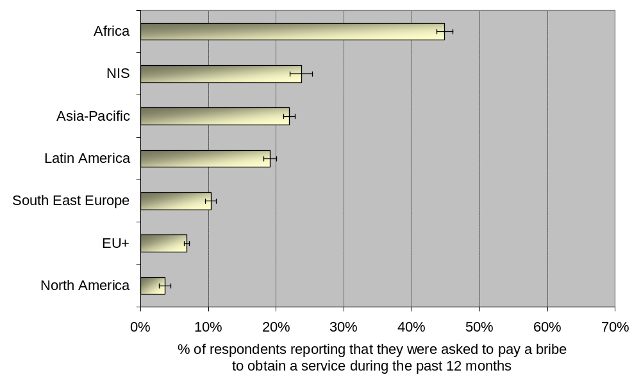
Source: Transparency International Global Corruption Barometer 2007. Percentages are weighted and calculated for those respondents who came in contact with the services listed. Thin lines indicate confidence intervals at 95%.

Countries most affected by petty bribery include Albania, Cameroon, FYR Macedonia, Kosovo, Nigeria, Pakistan, Philippines, Romania and Senegal. Table 1 below groups countries in quintiles based on reported bribery for services. (See also Table 4.1 in Appendix 4.)

Table 1. Countries most affected by bribery
 | Quintile | Countries/Territories
% of respondents reporting they paid a bribe to obtain a service | Top quintile:  More than 30% | Albania, Cambodia, Cameroon, FYR Macedonia, Kosovo, Nigeria, Pakistan, Philippines, Romania, Senegal
 | Second quintile:  17 – 29% | Bolivia, Dominican Republic, Greece, India, Indonesia, Lithuania, Moldova, Peru, Serbia, Ukraine
 | Third quintile:  8 – 16% | Bulgaria, Croatia, Czech Republic, Luxembourg, Malaysia, Panama, Russia, Turkey, Venezuela, Vietnam
 | Fourth quintile:  4 – 7% | Argentina, Bosnia-Herzegovina, Finland, Hong Kong, Ireland, Portugal, South Africa, Spain, United Kingdom, United States
 | Bottom quintile: Less than 3% | Austria, Canada, Denmark, France, Iceland, Japan, South Korea, Netherlands, Sweden, Switzerland
Source: Transparency International Global Corruption Barometer 2007.

Bribery: the poor must pay most of all

The Barometer 2007 found that respondents from low and middle income brackets are hit the hardest by petty bribery, as they are more likely than those from a high income bracket to pay bribes when seeking key services (Figure 2). This result holds true regardless of whether respondents were from richer or poorer countries: those who earn less must pay more often all over the world.

Figure 2. Experience of bribery worldwide, selected services
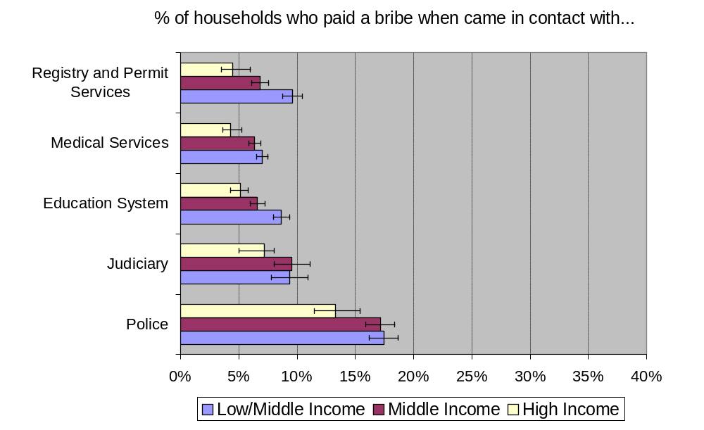
Source: Transparency International Global Corruption Barometer 2007. Thin lines indicate confidence intervals at 95%. Percentages are weighted. Services listed are among those reported by respondents to be most affected by bribery.

According to the Barometer 2007, women were less likely to pay a bribe than men. This does not mean that women are less corrupt than men, per se. Men reported more contact with institutions and services, such as the police and judiciary, where demands for bribery are more likely to occur.

The Barometer 2007 results also show that younger people are more likely to pay bribes than older people. Exploring the relationship between respondents’ age and experience with bribery reveals that while 18 percent of those under 30 years old paid a bribe when asked, only 4 percent of citizens over age 65 did the same. This difference can be explained by the fact that older citizens rarely reported contact with agencies, such as the police or the judiciary, where demands for bribes were most prevalent. Overall, the Barometer 2007 findings show a decreased likelihood to bribe corresponding to an increase in age (Table 2).

Table 2. Percentage of respondents reporting that they paid a bribe to obtain a service

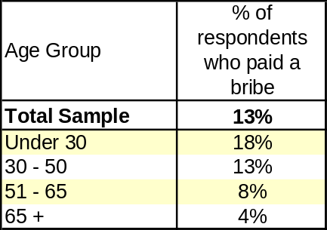
Source: Transparency International Global Corruption Barometer 2007. Percentages are weighted and calculated for respondents who came in contact with services.

Police is the public institution reported as most affected by petty bribery

In the Global Corruption Barometer 2007, the general public was asked whether a bribe was demanded from them when they had contact with key public services such as the education sector, the health system, the judiciary and legal system, the police, registry and permit services, tax authorities or a number of utility providers – telephone, electricity, water and gas.

Out of the eleven services, citizens reported that contact with the police far and away involves the biggest bribery problem. One in every four citizens around the world who had contact with the police was asked to pay a bribe – and one of every six citizens reported that they ended up paying such a bribe. Bribery is also reported to be a considerable problem for the judiciary, registry and permit services, education and medical services as well as electricity providers.

The fact that the judiciary emerges as the sector, after the police, most affected by bribery casts serious doubts about citizens being guaranteed their democratic right to equal access to courts. Institutions such as the judiciary and the police are in charge of sanctioning corruption-related acts – if they are beset by bribery, as the Barometer 2007 indicates, then the very enforcement mechanisms that are crucial for effective anti-corruption efforts are hindered, and public trust is undermined.

The Barometer 2007 indicates that petty corruption is significantly less of a problem for services such as tax revenue authorities, as well as for water, gas and telephone providers (Figure 3).

Figure 3. Experience with bribery, by service
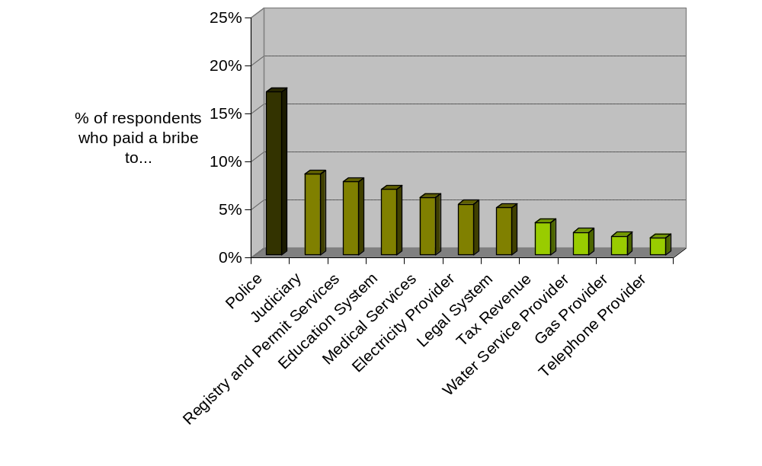
Source: Transparency International Global Corruption Barometer 2007. Percentages are weighted and calculated for respondents who came in contact with the services listed. Shading of the services represents the groups identified by cluster analysis, according to degree of reported bribery.

Different regions, different bribery challenges

Although the police is the institution most affected by bribery in five out of the seven regions (Africa, Asia-Pacific, NIS, Latin America and South East Europe), a closer look at these results uncovers substantial regional differences. Firstly, countries in the EU+ region report that out of the 11 services, medical services stand out as the most affected by bribery. Secondly, petty corruption is a serious problem in the judiciary for countries from Latin America, Asia-Pacific and North America. Finally, bribery in the education and health sectors, two of the most important sectors for human development, is a serious problem in Africa and NIS (Figure 4).

Figure 4. Selected Services: Percentage of respondents who paid a bribe, by region
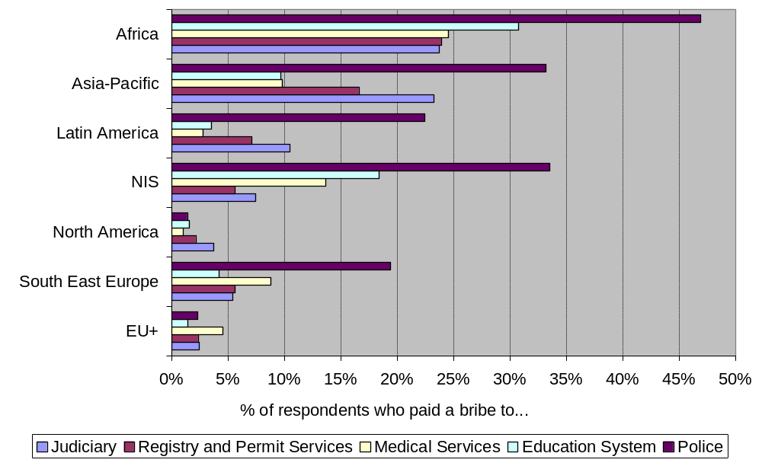
Source: Transparency International Global Corruption Barometer 2007. Percentages are weighted and calculated for respondents who came in contact with the services listed.

Petty bribery – is it growing?

Between 2006 and 2007 the proportion of citizens who reported paying bribes to obtain a service remained the same, around 12 percent. However there has been a marked increase in bribe paying in countries from the Asia-Pacific and South East Europe regions. In Africa and Latin America there has been a slight reduction in the percentage of respondents reporting having paid a bribe to obtain a service (Figure 5).

Figure 5. Comparing Bribery: 2006 and 2007
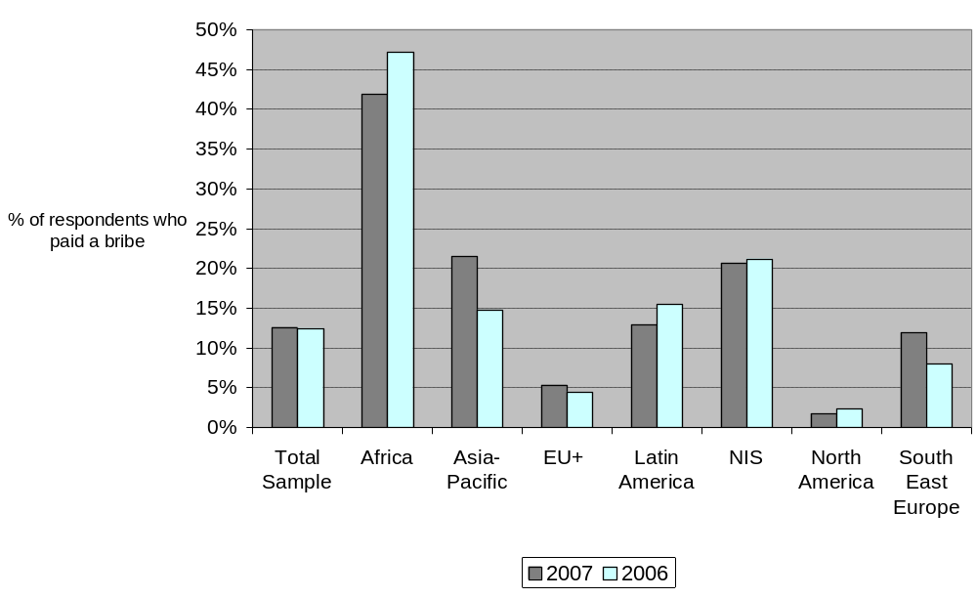
Source: Transparency International Global Corruption Barometer 2006 and 2007. Percentages are weighted and calculated for respondents who came in contact with services.

Corruption in key institutions: Political parties and the legislature viewed as most corrupt

As in past editions, the Barometer 2007 also examines the extent to which people perceive that corruption affects key public sectors and institutions in their country – as opposed to their direct experience of bribery, explored above.

Political parties and the legislative branch – meaning parliament and congress – are perceived by people around the world to be the institutions most tainted by corruption. In addition, the police stood out as significantly more affected by corruption than other institutions and service sectors. On the more positive side, non-governmental organisations (NGOs), religious bodies and the military lead the group of institutions perceived by citizens to be the least affected by corruption (Figure 6). These findings are in line with past editions of the Global Corruption Barometer.

Perceptions about levels of corruption can influence the public’s dealings with these institutions, undermine effective support and create a disconnect between those governing and those governed. In the case of institutions with which the public has direct contact, perceptions of endemic corruption create the expectation that graft is necessary to obtain services. Corruption in the system then becomes a self-fulfilling prophecy, as people pay where they assume it is necessary.

Figure 6. Perceived levels of corruption in key institutions, worldwide
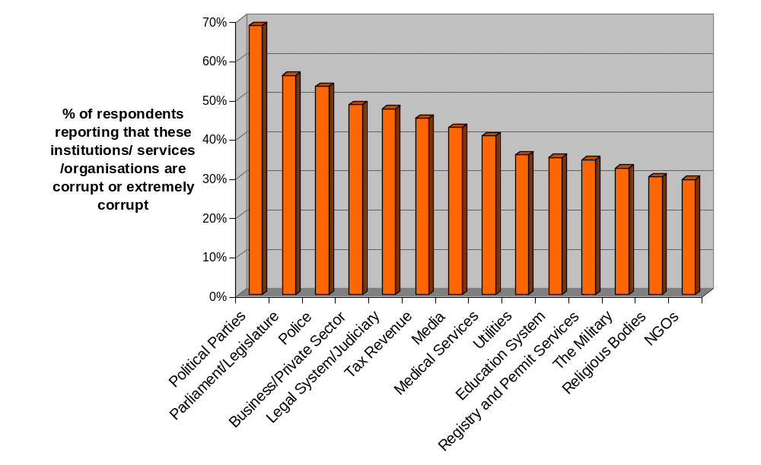
Source: Transparency International Global Corruption Barometer 2007. Percentages are weighted.

Numerous differences emerge in the public’s view of corruption in institutions across countries. Political parties are considered to be corrupt by more than four in five respondents in Argentina, Bosnia and Herzegovina, Bulgaria, Bolivia, Cameroon, India, Japan, Panama and Nigeria – but by fewer than two in five in Denmark, Netherlands, Norway, Sweden, Switzerland and Singapore. Likewise, while more than four in five respondents in Cameroon, Ghana, India and Nigeria consider the police to be corrupt, fewer than two in five in Denmark, Germany, Finland, Singapore, Sweden and Switzerland report the same. (See Table 4.2 in Appendix 4.)

In general, citizens’ perceptions about corruption in key institutions have not changed dramatically over the past four years. But opinion about some institutions, such as the private sector, has deteriorated over time. This means that the public now has more critical views of the role of business in the corruption equation than it did in the past. Comparing 2004 and 2007 data, more people around the world also consider non-governmental organisations to be corrupt. In contrast, the proportion of people around the world who consider the judiciary, parliament, the police, tax revenue authorities and medical and education services to be corrupt has decreased somewhat in the past four years (Figure 7).

Figure 7. Perceived levels of corruption in key institutions, comparing 2004 and 2007
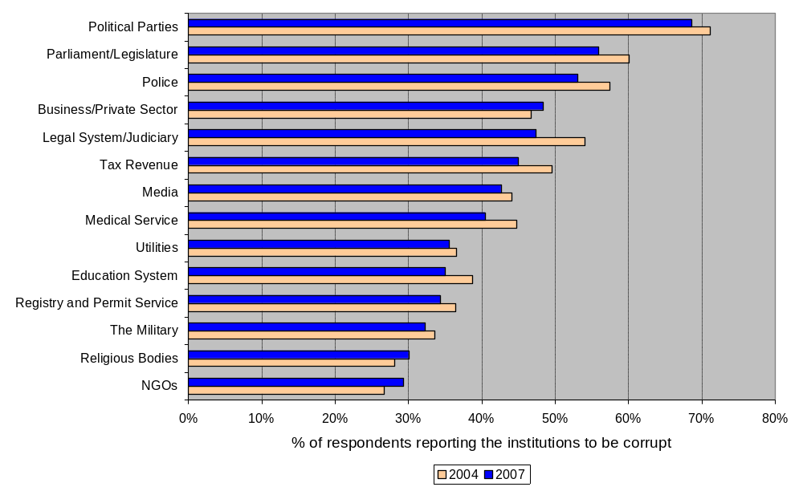
Source: Transparency International Global Corruption Barometer 2004 and 2007. Percentages are weighted and represent percentage of respondents reporting that the institutions are considered corrupt or extremely corrupt.

Experience v. perceptions of corruption – do they align?

The experience and perceptions of corruption reported by the general public in the Barometer correspond to a great extent. According to this year’s results, there is a strong link between people’s perception of corruption in key services and their experience with bribery when coming in contact with the same services. The more likely the average citizen is to be confronted with bribery in a particular institution, the more they will indicate they believe corruption affects that institution. For example, police are most frequently reported as the institution demanding bribes, and they are also viewed as highly corrupt around the world.

Moreover, the Barometer 2007 findings also show a strong correlation between citizens’ experiences with bribery and experts’ perceptions of corruption. Figure 8 shows the link between the general public’s experiences, gathered in the Global Corruption Barometer 2007, and experts’ views, as captured in TI’s Corruption Perceptions Index 2007. The results are clear: in those countries where business people, country analysts and experts perceive corruption to be widespread, a higher proportion of citizens are paying bribes to obtain a service. This suggests that expert opinion is aligned with citizens’ experiences in terms of public sector corruption.

Figure 8. Corruption Perceptions Index v. citizens’ experience with bribery
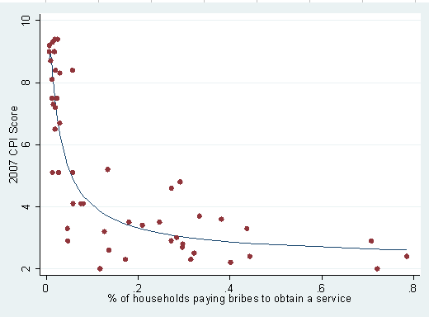
Source: Transparency International Global Corruption Barometer 2007 and Corruption Perceptions Index 2007. Each dot represents a country.

Levels of corruption expected to rise over the next three years

More than half of the citizens polled around the world expect the level of corruption to increase to some degree over the next three years. Only one in every five respondents expected the level of corruption to decrease in the near future, while one in four expect the level of corruption to be the same (Figure 9).

Figure 9. Corruption will get worse, worldwide
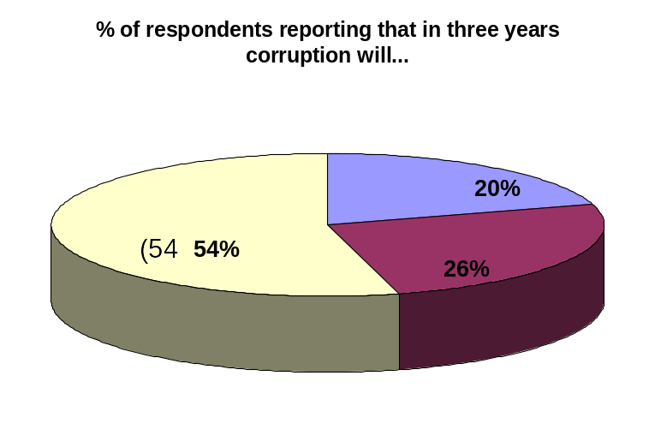
Source: Transparency International Global Corruption Barometer 2007. Percentages are weighted.

Among the most pessimistic countries are India, Philippines, Senegal, South Africa, Netherlands and the United Kingdom, where more than 70 percent of the respondents expect the level of corruption to increase in the coming three years. In contrast, interviewees in Ghana, FYR Macedonia, Kosovo and Nigeria are more optimistic – with more than 45 percent expecting corruption to decrease in the next three years (Table 4.1 in Appendix 4).

Detailed analysis reveals that women are slightly more pessimistic than men about future levels of corruption. Income levels are also a significant factor: low income citizens are more pessimistic than high income citizens, with three in five low income citizens expressing the view that corruption will increase, as compared to one in two high income citizens.

A discouraging finding is that public expectations about the extent of corruption in the future have become gloomier over time. In 2003, 43 percent of all interviewees expected corruption to increase in the next three years, but in 2007 this increased to 54 percent. As Figure 10 shows, however, important differences emerge when analysing trends by region.

In Africa people seem to be more optimistic now than they were five years ago: in 2007, three in ten Africans polled expect corruption levels to increase; in 2003, substantially more – five in ten – expected the same. This pattern is also true for South East Europe and the NIS, although less marked. On the contrary, in the Asia-Pacific region, people’s expectations have substantially deteriorated. In 2003, just three out of ten expected corruption in their countries to increase. By 2007 a full six out of ten in Asia-Pacific countries expect that corruption levels will be worse in the future. Likewise, in comparison to 2003, a bigger proportion of citizens in Latin America and the EU+ now expect that corruption will increase in their country in the near future.

Figure 10. Expectations about the future: Comparing 2003 and 2007
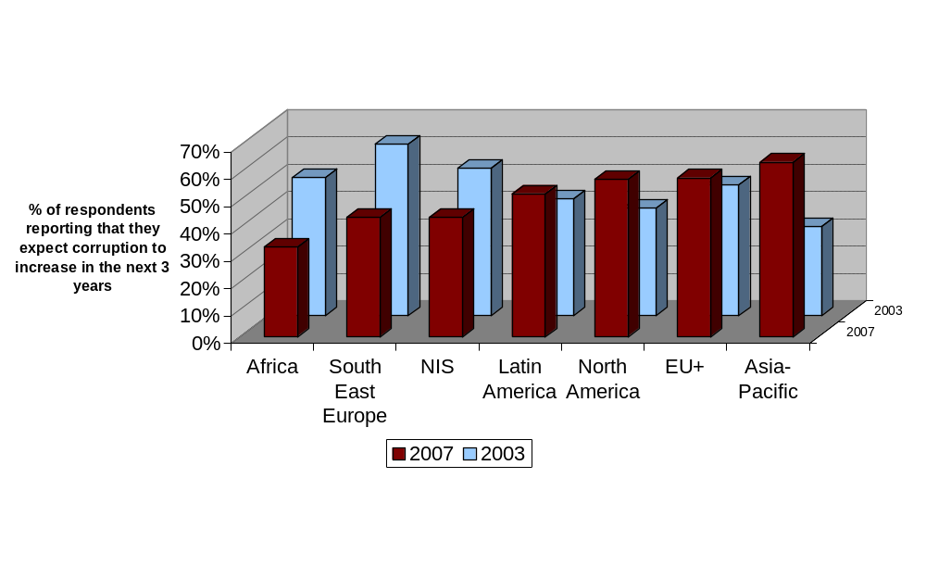
Source: Transparency International Global Corruption Barometer 2003 and 2007. Percentages are weighted.

Public scepticism of government efforts to fight corruption – in most places

Citizens around the world are critical about the effectiveness of their government’s efforts to fight corruption. One in two citizens around the world thinks that their government is not doing a good job fighting corruption. Only one in three believes the opposite – that government efforts are effective. A closer look reveals that the greatest differences emerge between countries. Table 3 lists countries where respondents believe their government’s efforts to fight corruption are most and least effective.

Table 3. How effectively is government fighting corruption? The country view
Countries who believe government efforts to fight corruption are most effective | Countries who believe government efforts to fight corruption are least effective
Colombia  Dominican Republic  Ecuador  FYR Macedonia  Ghana  Hong Kong  Ireland  Malaysia  Nigeria  Singapore  Turkey | Albania  Argentina  Bulgaria  Czech Republic  Iceland  Japan  Lithuania  Norway  Peru  Russia  Ukraine  United States
Source: Transparency International Global Corruption Barometer 2007. Countries were sorted in quintiles based on responses from 1 (very effective) to 5 (very ineffective). Countries listed belong to the top and bottom quintile. For the complete list of country results see Table 4.4 in Appendix 4.

On average, all regions except Africa are very sceptical about the effectiveness of their government’s actions against corruption. In Africa, however, Ghana and Nigeria are very positive and dominate this result; Cameroon, South Africa and Senegal are more critical of government efforts. North Americans and EU+ citizens report very negatively on government efforts, while at the same time they are the least likely to have to make petty bribes themselves. This suggests that citizens there may be concerned about problems of grand corruption and state capture. In addition, in North America and the EU+ relatively few governments have explicit anti-corruption strategies or policies, meaning that there may be little generalised attention to anti-corruption efforts in the public domain. Criticism of government efforts in the Asia-Pacific region might be linked to the fact that more citizens there report involvement in petty bribery as compared to last year.

Conclusions

The findings of the Global Corruption Barometer 2007 offer clear evidence that corruption affects ordinary people everywhere regardless of where they live or what they earn. The poorest in all societies are the ones hit the hardest by bribery, however, as they face the most demands for bribes and they are more likely to pay. This in turn means that corruption acts as a regressive tax that increases income inequality. Denied their basic rights and free access to public services, the poor suffer most in corrupt environments. Their pessimism about prospects for corruption being reduced in the future is another sign of disenfranchisement.

The Global Corruption Barometer 2007 shows that the general public continues to view parliaments and political parties as the institutions most tainted by corruption around the world, while the direct experience of those polled points to highest levels of bribery in the police and the judiciary. The result is that key institutions in society, in particular institutions central to the integrity and accountability of government, are compromised. There can be little doubt that corruption undermines the legitimacy of government and those who govern in many countries.

The Barometer 2007 also sheds light on a discouraging fact: relative to 2006, petty bribery has not lessened, but indeed has increased in several countries around the globe. This climate of extortion undermines efforts to root out corruption – as well as public hope that the situation can improve in the future.

Worldwide, the general consensus is that government efforts to stop corruption are not effective and that corruption will increase in the near future. The results of the Global Corruption Barometer 2007 show that governments need to work harder to clean up basic services and to prove to their constituencies that they are committed to fighting corruption in word and deed. But governments are not the only group responsible for making anti-corruption initiatives effective. All anti-corruption stakeholders, whether in government, in the private sector or in civil society, must redouble efforts to make progress and demonstrate results in the struggle against malfeasance and graft.

The Global Corruption Barometer 2007 reveals that views and experiences of corruption among ordinary people vary, as corruption has many faces around the world. Anti-corruption strategies need to reflect these crucial differences at country level, matching solutions to local concerns and problems. It is urgent that anti-corruption reforms create results that have real impact on people’s lives and that offer people a future where corruption no longer robs them of opportunities – or hope.

Appendix 1: The Global Corruption Barometer 2007 Questionnaire

Now we would like to ask you a few questions about corruption. In this survey we are using corruption to mean the abuse of entrusted power – by a public official or a businessperson for example – for private gain. This could include material gain or other benefits.

1. Do you expect the level of corruption in the next 3 years in this country to change? Will it: READ OUT – SINGLE CODE
Increase a lot | 1
Increase a little | 2
Stay the same DO NOT READ OUT | 3
Decrease a little | 4
Decrease a lot | 5
Don’t know/no response | 9

2. How would you assess your current government’s actions in the fight against corruption?
READ OUT AND ROTATE - SINGLE CODE

The government is very effective in the fight against corruption | 1
The government is somewhat effective in the fight against corruption | 2
The government is neither effective nor ineffective in the fight against corruption DO NOT READ OUT | 3
The government is somewhat ineffective in the fight against corruption | 4
The government is very ineffective in the fight against corruption | 5
DK/NA | 9

3. To what extent do you perceive the following categories in this country to be affected by corruption? Please answer on a scale from 1 to 5 (1 meaning not at all corrupt, 5 meaning extremely corrupt). Of course you can use in-between scores as well. READ OUT AND ROTATE - SINGLE CODE FOR EACH

Sectors | Not at all corrupt |  |  |  | Extremely corrupt | DK/NA
Political parties | 1 | 2 | 3 | 4 | 5 | 9
Parliament/Legislature | 1 | 2 | 3 | 4 | 5 | 9
Business/ private sector | 1 | 2 | 3 | 4 | 5 | 9
Media | 1 | 2 | 3 | 4 | 5 | 9
The military | 1 | 2 | 3 | 4 | 5 | 9
NGOs (non governmental organizations) | 1 | 2 | 3 | 4 | 5 | 9
Religious bodies | 1 | 2 | 3 | 4 | 5 | 9
Education system | 1 | 2 | 3 | 4 | 5 | 9
Legal system/Judiciary | 1 | 2 | 3 | 4 | 5 | 9
Medical services | 1 | 2 | 3 | 4 | 5 | 9
Police | 1 | 2 | 3 | 4 | 5 | 9
Registry and permit services (civil registry for birth, marriage, licenses, permits) | 1 | 2 | 3 | 4 | 5 | 9
Utilities (telephone, electricity, water, etc.) | 1 | 2 | 3 | 4 | 5 | 9
Tax revenue | 1 | 2 | 3 | 4 | 5 | 9

4. In the past 12 months, have you or anyone living in your household had a contact with the following institution/organisation? READ OUT AND ROTATE. SINGLE CODE FOR EACH
INTERVIEWER: Living in household = people included in your house e.g. parents, children, etc

ASK FOR EACH INSTITUTION MENTIONED WITH CODE 1 (YES) IN Q6 IF NONE MENTIONED, GO TO Q7.1
4.1 In the past 12 months have you or anyone living in your household been requested a bribe from someone in the following institution/ organization?

ASK FOR EACH INSTITUTION MENTIONED WITH CODE 1 (YES) IN Q6
4.2 In the past 12 months have you or anyone living in your household paid a bribe in any form to each of the following institution/organisation?

A4
4.3. what was the cost of the last bribe paid?
iNTERVIEWER: to be asked in local currency but coded by you in euros according to the currenCy exchange submitted by your company - IF CaNNOT specify AmoUNT LEAVE IT BLANK

 | Q4 |  |  |  | Q4.1 |  |  |  | Q4.2 |  |  |  | Q4.3
Sectors | Had a contact |  |  |  | Was requested to pay a bribe |  |  |  | Paid a bribe |  |  |  | cost of last bribe
 | YES | NO | DK | NA | YES | NO | DK | NA | YES | NO | DK | NA | Col
Education system | 1 | 2 | 8 | 9 | 1 | 2 | 8 | 9 | 1 | 2 | 8 | 9
Legal system | 1 | 2 | 8 | 9 | 1 | 2 | 8 | 9 | 1 | 2 | 8 | 9
Judiciary | 1 | 2 | 8 | 9 | 1 | 2 | 8 | 9 | 1 | 2 | 8 | 9
Medical services | 1 | 2 | 8 | 9 | 1 | 2 | 8 | 9 | 1 | 2 | 8 | 9
Police | 1 | 2 | 8 | 9 | 1 | 2 | 8 | 9 | 1 | 2 | 8 | 9
Registry and permit services (civil registry for birth, marriage, licenses, permits, land and property ownership and transfer of ownership) | 1 | 2 | 8 | 9 | 1 | 2 | 8 | 9 | 1 | 2 | 8 | 9
Telephone | 1 | 2 | 8 | 9 | 1 | 2 | 8 | 9 | 1 | 2 | 8 | 9
Electricity Provider | 1 | 2 | 8 | 9 | 1 | 2 | 8 | 9 | 1 | 2 | 8 | 9
Water Service Provider | 1 | 2 | 8 | 9 | 1 | 2 | 8 | 9 | 1 | 2 | 8 | 9
Gas Provider | 1 | 2 | 8 | 9 | 1 | 2 | 8 | 9 | 1 | 2 | 8 | 9
Tax revenue | 1 | 2 | 8 | 9 | 1 | 2 | 8 | 9 | 1 | 2 | 8 | 9

Appendix 2: The Global Corruption Barometer – About the Survey

The Global Corruption Barometer is a public opinion survey that assesses the general public’s perceptions of corruption and experience with bribery. In most of the countries evaluated, the survey is carried out on behalf of Transparency International by Gallup International as part of its Voice of the People Survey. In other countries, TI commissions polling organisations to run the survey specifically for the Barometer. The TI Global Corruption Barometer 2007 includes 63,199 respondents.

Coverage
Overall, the Voice of the People survey was conducted in 60 countries. However, in some countries some of the questions were omitted from the survey (e.g. in Germany and Italy, question 6 was omitted from the survey). Moreover, not all questions were asked in Vietnam and problems in the coding of responses for Colombia, Ecuador, Ghana, Guatemala, Norway, Poland, Thailand and Singapore prevented us from using some data.

Timing of fieldwork
The fieldwork for the survey was conducted between June and September 2007.

Demographic variables
The demographic variables Age, Education, Household income, Education, Employment and Religion were recoded from their original form in the survey by Gallup International.

Sampling
The sample type is mostly national, but in some countries it is urban only. It should be underlined that in global terms the findings are quite heavily based on urban populations. In most of the countries the sampling method is based on quota sampling, using sex/age/socioeconomic condition/regional/urban balances as variables. In some countries random sampling has been done.

The interviews were conducted either face to face, using self-administered questionnaires, by telephone or internet (mostly in developed countries) with male and female respondents, aged 15+.

Weighting
Sample imbalances in the data within a country (e.g. slight corrections to the proportions of age groups, sex, etc.) have been weighted first in order to provide a representative sample of the national population (or a representative sample of the stated universe, if this is not a total population sample). Subsequently, each country has been weighted to its relevant population (universe). For example, countries where only the urban population was interviewed were weighted up to a total urban population.

Data coding, quality check and analysis
The data coding and quality check, as well as preliminary analysis, was done by Gallup International.
The full report of the TI Global Corruption Barometer 2007 was completed by Robin Hodess and Juanita Riaño of the Policy and Research Department at the International Secretariat of TI. Professor Richard Rose of Aberdeen University, a member of TI’s Index Advisory Committee, also contributed advice on the Barometer data.

A standard margin of error for the survey is +/- 4.

For further information on any individual country results, please see contact information below:

Country | Contact | E-mail | Company | Mode | Sample  Type | Size | Fieldwork  Dates
Albania | Maria Dede | maridede@albnet.net | TNS Index Albania GIA | Face-to-face | National | 1000 | August 8 – August 17
Argentina | Constanza Cilley | constanza.cilley@tns-gallup.com.ar | TNS Gallup Argentina | Face-to-face | National | 1010 | August 18–  August 22
Austria | Ingrid Lusk | i.lusk@gallup.at | Karmasin Marktforschung Gallup Österreich | Face-to-face | National | 804 | July 12 – August 13
Bolivia | Luis Alberto Quiroga Arce | proyectos@encuestas-estudios.com | Encuestas & Estudios | Face-to-face | Urban | 1364 | June 26 – July 31
Bosnia and Herzegovina | Aida Hadziavdic-Begovic | aida.hadziavdic@mib.ba | Mareco Index Bosnia | Telephone | National | 500 | June 7 – June 15
Bulgaria | Marin Stoychev | m.stoychev@gallup-bbss.com | TNS BBSS Gallup International | Face-to-face | National | 1016 | June 25 – July 7
Cambodia | Kay Engelhardt | kay.engelhardt@tns-global.com | TNS Vietnam | Face-to-face | National | 1016 | September 16- September 28
Cameroon | Placide Yaptie | pyaptie@rms-international.net | RMS  Cameroon | Face-to-face | Douala & Yaoundé | 519 | August 15 – August 20
Canada | Diane Rousseau | drousseau@legermarketing.com | Leger Marketing | Telephone | National | 1007 | July 4 – July 20
Colombia | Cristina Querubin | cquerubin@cnccol.com | Centro Nacional de Consultoría | Telephone | Urban | 600 | July 9 - July 16
Croatia | Mirna Cvitan | Mirna.cvitan@puls.hr | PULS d.o.o. | Face-to-face | National | 1000 | August 2–  August 19
Czech Republic | Jan Trojacek | trojacek@mareco.cz | Mareco s.r.o. | Face-to-face | National | 1000 | June 6 – June 16
Denmark | Jens Daugaard | Jens.Daugaard@tns-gallup.dk | TNS Gallup | CAWI | National | 1118 | June 20 – June 26
Dominican* Republic | Leonard Kemp | l.kemp@sigmados-international.com | SIGMA DOS | Face-to-face | Urban | 471 | August 8 - August 14
Finland | Mirva Väyrynen | mirva.vayrynen@tns-gallup.fi | TNS Gallup | Online panel | National | 1154 | June 8 – June 13
France | Marc-André Allard | marc-andre.allard@tns-sofres.com | TNS Sofres | Face-to-face | National | 1000 | July 25- July 28
Germany | Johannes Huxoll | johannes.huxoll@tns-emnid.com | TNS Emnid | Telephone | National | 500 | August 24 – August 25
Ghana | Dinesh Kithany | dkithany@rms-africa.com | RMSI Ghana | Face-to-face | National | 2003 | July 11 – July 23
Greece | Ero Papadopoulou | ero.papadopoulou@tnsicap.gr | TNS ICAP | Telephone | Urban | 1000 | July 12 – August 6
Guatemala | Edgar Estr | edgarest@gmail.com | Multivex-Sigma Dos Guatemala | Face-to-face | Urban | 500 | September 14 – September 17
Hong Kong | Winnie Yiu | winnie.yiu@tns-global.com | TNS | Online panel | National | 1006 | August 2 – August 14
Iceland | Gudbjorg Andrea Jonsdottir | gudbjorg.andrea.jonsdottir@capacent.is | Capacent Gallup | Net panel | National | 1081 | July 3 – July 25
India | Suvigya Rathi | suvigya.rathi@tns-global.com | TNS India | Face-to-face | Urban | 1069 | July 16 – July 27
Indonesia | Widya Ria Kencana | Widya.Kencana@tns-global.com | TNS  Indonesia | Face-to-face | Urban | 1010 | August 4– August 21
Ireland | Jon Coll | jon.coll@tns-global.com | TNS mrbi | Telephone | National | 1020 | June 10 – June 19
Italy | Paolo Colombo | paolo.colombo@doxa.it | Doxa s.p.a | Telephone | National | 1000 | July 12 – July 16
Japan | Kiyoshi Nishimura | nisimura@nrc.co.jp | Nippon Research Center, Ltd. | Combination of “face-to-face” and “self-administered questionnaire” | National | 1200 | August 1– August 13
Kosovo* (UN Administration) | Assen Blagoev | a.blagoev@gallup-bbss.com | BBSS-Index Kosovo | Face-to-face | Albanian plus population | 504 | August 11–  August 16
Lithuania* | Vladas Gaidys | vladas@vilmorus.lt | Vilmorus | Face-to-face | National | 1001 | September 6 – September 9
Luxembourg | Louis Mevis | Louis.mevis@tns-ilres.com | TNS ILRES | Online Panel | National | 504 | August 2 – August 7
Macedonia | Ivana Ivanovic | office@brima-gallup.com.mk | BRIMA | Face-to-face | National | 1141 | July 2 – July 11
Malaysia | Bee Yoke Yang | BeeYoke.Yang@tns-global.com | TNS Malaysia | Face-to-face | Peninsula Malaysia Urban | 1250 | July 2 – August 5
Moldova* | Jigau Ion | office@cbs-axa.org cbs_axa@yahoo.com | Joint venture “CBS AXA” Ltd | Face-to-face | National | 1237 | August 1 – August 15
Netherlands | Dagmar Strikwerda | Dagmar.strikwerda@tns-nipo.com | TNS Nipo | CASI | National | 1009 | August 11 – August 23
Nigeria | Femi Laoye | olaoye@rms-africa.com | RMS | Face-to-face | National | 5017 | July 12 – July 25
Norway | Elise Wedde | elise.wedde@tns-gallup.no | TNS Gallup Norway | Web Interviews | Nationally representative of Internet-population | 1006 | August 17- August 29
Pakistan | Fatima, Idrees | fatima.idrees@gallup.com.pk | Gallup Pakistan | Face-to-face | National | 1013 | June 25 – July 5
Panama* | Max Del Cid | psmcorreo@cwpanama.net | PSM SIGMA DOS PANAMA | Telephone | Urban | 685 | July 25 – August 18
Peru | Gustavo Yrala | gyrala@datum.com.pe | DATUM Internacional S.A. | Face-to-face | National | 1133 | August 3 – August 7
Philippines | Raymund Pascua | raymund.pascua@asiaresearch.com.ph | Asia Research Organization Inc. | Face-to-face | National | 1000 | July 17 – August 12
Poland | Marek Fudała | marek.fudala@mareco.pl | Mareco Polska | Face-to-face | Urban | 1048 | August 27 – August 31
Portugal | Ana Paraíba | ana.paraiba@tns-global.com | TNS Euroteste | Telephone | National | 1000 | July 4 - July 17
Romania | Janina Stancicu | janina.stancicu@csop.ro | TNS - CSOP | Face-to-face | National | 1054 | June 25 – July 2
Russia | Victor  Pratusevich | Pratusevich.V@rmh.ru | Romir Monitoring | Face-to-face | National | 1573 | June 15 – June 21
Senegal* | Erckman TOGNA | etogna@rms-international.net | RMS-Senegal | Face-to-face | Urban | 507 | June 22 – June 25
Serbia | Sladjana Brakus | sladja@tnsmediumgallup.coyu | TNS Medium Gallup | Face-to-face | National | 1003 | June 13 - June 19
Singapore | Jasmine Yang | Jasmine.Yang@tns-global.com | TNS Singapore Pte.Ltd. | Telephone | National | 1020 | July 18 – August 21
South Africa | Mari Harris | marih@markinor.co.za | Markinor | Telephone | National | 1496 | August 2–  August 7
South Korea | Hwanhee Lee | hhlee@gallup.co.kr | Gallup Korea | Face-to-face | National | 1001 | June 5- June 19
Spain | Josefina Fernández | josefinaf@sigmados.com | Sigma Dos | Telephone | National | 1000 | June 1 – August 10
Sweden | Matz Johansson | matz.Johansson@tns-gallup.se | TNS Gallup AB | Online interviews | National | 1000 | August14 –  August 20
Switzerland | Nadja Mueller | nadja.mueller@isopublic.ch | ISOPUBLIC AG | Face-to-face | National | 1037 | July/ –  August
Thailand | Tippayarat Wudhiprecha | tippayarat.wudhiprecha@tns-global.com | TNS | Telephone | National | 500 | August 18 – August 29
Turkey | Bengi Ozboyaci | bengi.ozboyaci@tns-global.com | TNS Piar | Face-to-face | National | 2015 | June 7– July 4
UK | Emma Dolby | emma.dolby@tns-global.com | TNS | Telephone | National | 1000 | August 24 – August 26
Ukraine | Alla Vlasyuk | Alla.vlasyuk@tnsofres.com.ua | TNS Ukraine | Face-to-face | National | 1200 | May 31 – June 7
USA | Joe Vogt | Joe.vogt @tns-global.com | TNS | Online | National | 1019 | August 2 – August 16
Venezuela | Romel Romero | romel@sigmados-international.com | Sigma Dos Venezuela | Face-to-face | Urban | 1058 | August 18 – September 11
*These are not Members of Gallup International Association but reliable companies that we have worked with in these countries.

Appendix 3: Regional Groupings

Global Corruption Barometer 2007

Africa: Cameroon; Ghana; Nigeria; Senegal; and South Africa.
Asia-Pacific: Cambodia; Hong Kong; India; Indonesia; Japan; Korea, south; Malaysia; Pakistan; Philippines; Singapore; Thailand; and Vietnam.
EU+: Austria; Bulgaria; Czech Republic; Denmark; Finland; France; Germany; Greece; Iceland; Ireland; Italy; Lithuania; Luxembourg; Netherlands; Norway; Poland; Portugal; Romania; Spain; Sweden; Switzerland; and United Kingdom.
Latin America: Argentina; Bolivia; Colombia; Dominican Republic; Ecuador; Guatemala; Panama; Peru; and Venezuela.
Newly Independent States (NIS): Moldova; Russia; and Ukraine.
North America: Canada and United States.
South East Europe: Albania; Bosnia-Herzegovina; Croatia; FYR Macedonia; Kosovo; Serbia; and Turkey.

Appendix 4: Country Tables

Table 4.1: Respondents who paid a bribe to obtain services
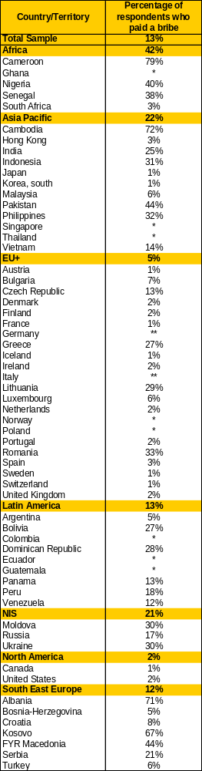
Source: Transparency International Global Corruption Barometer 2007. Percentages are weighted and calculated for respondents who came in contact with services.
* Due to problems with data, results for Colombia, Ecuador, Ghana, Guatemala, Norway, Poland, Thailand, and Singapore could not be used.
** In Germany and Italy this question was not asked.

Table 4.2: Corruption’s impact on different sectors and institutions
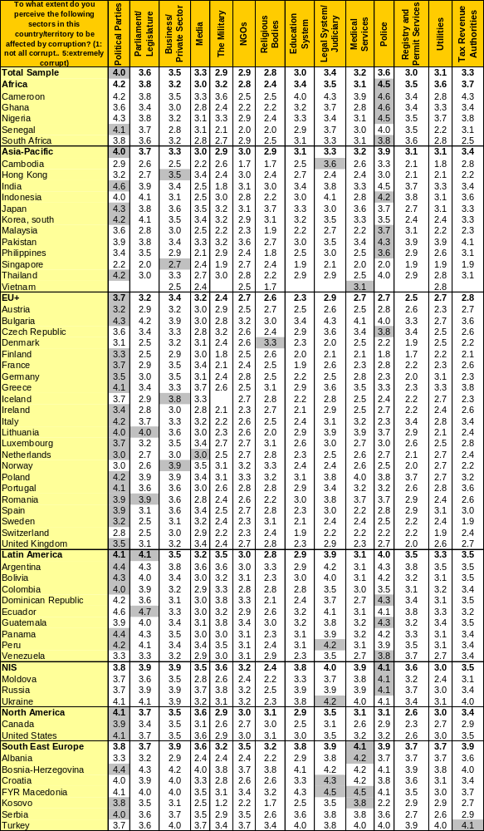
Source: Transparency International Global Corruption Barometer 2007. Figures are weighted. Shaded scores are the highest for that particular country.

Table 4.3: Views of corruption in the future
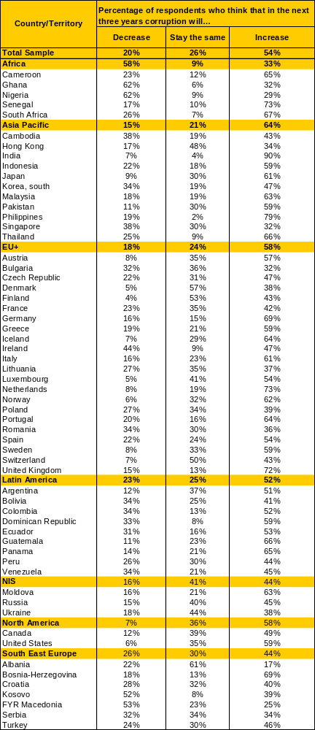
Source: Transparency International Global Corruption Barometer 2007. Percentages are weighted.

Table 4.4: Respondents' evaluation of their government's efforts to fight corruption
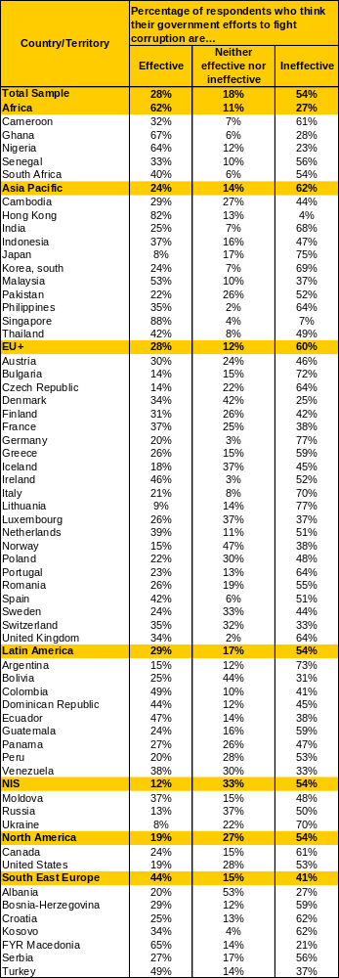
Source: Transparency International Global Corruption Barometer 2007. Percentages are weighted.

See Appendix 1 for the Global Corruption Barometer 2007 questionnaire.
See Appendix 2 for the methodological description of the survey.
The Barometer 2007 questionnaire was also carried out by TI in special surveys in Armenia, Cambodia, Georgia and Lithuania. However, due to timing issues, only results from Cambodia and Lithuania can be included in this report. We expect the results from Armenia and Georgia to be available in the coming months.
Countries not included by Gallup International in the June-September 2007 edition of the Voice of the People Survey, and therefore that cannot be included in the Global Corruption Barometer 2007, but that were included in the Barometer 2006, are Chile, Congo (Brazzaville), Fiji, Gabon, Israel, Kenya, Mexico, Morocco, Paraguay and Taiwan.
For the purposes of analysis, individual countries have been grouped into regions. While regional groupings pose some problems, they can highlight areas that have broadly similar characteristics and challenges. Combining regional data also strengthens the reliability of some findings. The groupings used in this report can be seen in Appendix 3.
Due to problems with data, results for Colombia, Ecuador, Ghana, Guatemala, Norway, Poland, Thailand, and Singapore could not be used. In Germany and Italy this question was not asked.
The regressiveness of bribery was tested by estimating a probit model that explains the probability of a household paying a bribe by the demographic characteristics of the respondent (gender, age, religion and education), income category and fixed regional effects. Even thought the overall explanatory power of the model is low (Pseudo R-Squared=0.1286), the coefficient of the income variable is negative and significant (p<0.05) which indicates that high income citizens have a lower probability of paying a bribe to obtain a service.
These three groups have been defined by cluster analysis, and are reflected in Figure 3.
Time comparisons in this report are made only for countries included in both editions of the Global Corruption Barometer (in this case 2006 and 2007) being compared.
Institutions/services were divided into three different groups using cluster analysis...
The correlation coefficient between the percentage of respondents reporting they paid a bribe to the judiciary, the police, the registry and permit services, utilities, tax authorities, and medical and education services and the percentage of respondents considering these services as corrupt is -.47 (p<0.01).
The correlation coefficient between the CPI 2007 and percentage of citizens paying bribes is -0.66 (p<0.01).
Although the Global Corruption Barometer 2007 questionnaire included a question on the cost of the last bribe paid, the data collected did not enable statistically robust conclusions to be reached and was therefore not included in this report.

